Bryant Hayes

March 30, 2016

HW 1 Individual Design Concept Proposal

## Design Concepts & Brainstorming

My design has three primary parts: a robotic arm for acting on the environment, a single camera for getting information about the environment, and the mechanical structure for maintaining a stable foundation for the other two parts. This breakdown shows that all three disciplines (ECE, CS & ME) will be needed for the project to be successful, but fortunately our group will be well equipped to handle all these challenges.

The Robotic Arm

The arm will be what interacts with the environment and holds the fishing rod. The arm will be a palletizing robotic arm design with 300mm total reach. The arm movement will be driven using three standard sized servomotors all located at the base of the arm. We will use cheaper servos to start, and upgrade if the need for more torque or speed arises. The arm will give us motion in the X, Y and Z directions and must be able to put the tip of the fishing rod on any part of our half of the playing field. We also will need to make sure that it is steady enough when idling so that there is not significant swing in the fishing rod. We will develop a library that makes it simple to input a 3D location in space, or on the board, and have the arm go to that position in the shortest time. The movement algorithms will be encapsulated in this class and will not need to be altered once established. The arm’s servos will receive commands from an Arduino Mega2560 micro-controller over PWM signals. The servos will be powered from a separate 6V 8A power source, which comes from a 12V 60W wall wart, stepped down to 6V with about 81% efficiency. The control scheme to actually move the arm will come from a computer connected to the Arduino board via Serial. The movements will be based on information gathered from the machine vision system. The arm will also have a small servo at the tip that allows for rotation motion of the fishing rod if needed.

Machine Vision System

The machine vision system will use a Cognex In-Sight 7000 camera that will enable us to offload a lot of the processing to the camera itself. We are not yet sure of the capabilities of this internal processing, but in general the job of the camera system will be to scan the playing field and determine the key points on the board that the fishes’ mouth will open. Once detecting these points, commands will be sent from the laptop to the Arduino board, eventually resulting in movement of the robotic arm. Depending on the rules of the game the camera may or may not be equipped with color detection capabilities. The camera will be mounted above the arm on a metal shaft that causes camera to remain steady, even when the robotic arm is moving.

Mechanical Structure

The robot’s body will be made of metal and will allow for a rigid connection to the robotic arm base as well as a tower component that will hold the machine vision camera. Along the base there will be some kind of sensors or marks that insure the robot is aligned correctly in relation to the board game. A panel in the rear of the robot will contain all electronics and circuit boards mounted with spacers. The main input to the system will be the 12V 60W wall wart, but besides that our goal is to make it small-medium sized, sturdy and very portable.

## Functional Goals

* Be able to accurately determine the X, Y location of a fish with their mouths open at any time.
* Be able to easily send movement commands from the laptop to the Arduino, which in turn control the robotic arm.
* Have little to no jitter in the robotic arm, and have smooth motion when moving.
* Be able to pick up as well as drop a fish with at least 50% accuracy (Fish is successfully grabbed at least every two attempts)

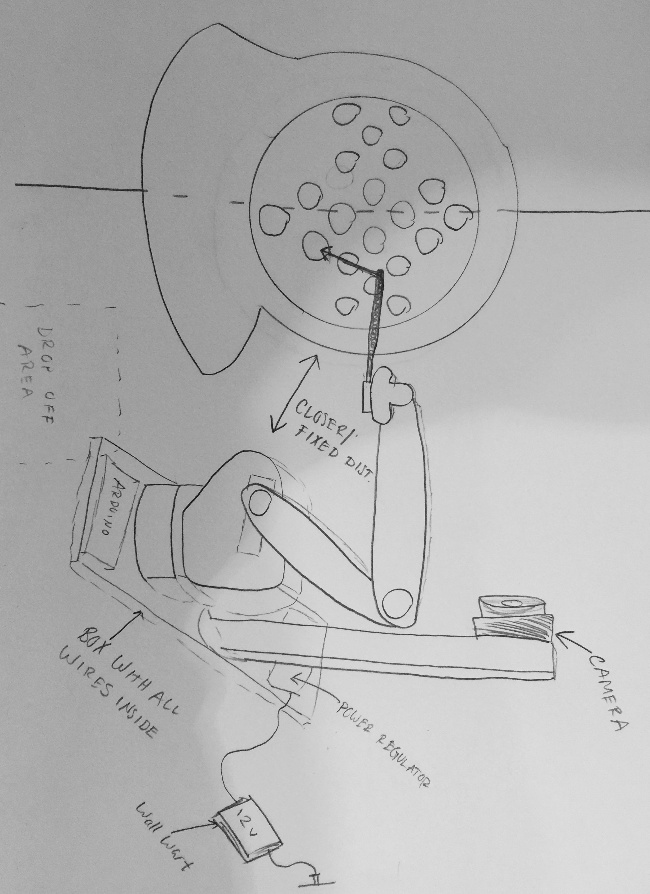

## Sketch of System

## Flowchart of Functions

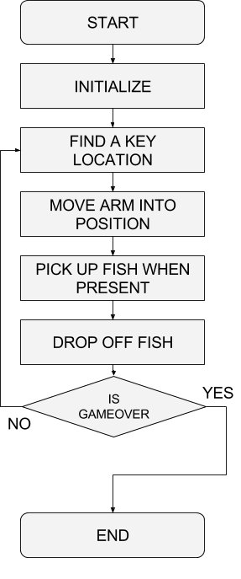

## Block Diagram

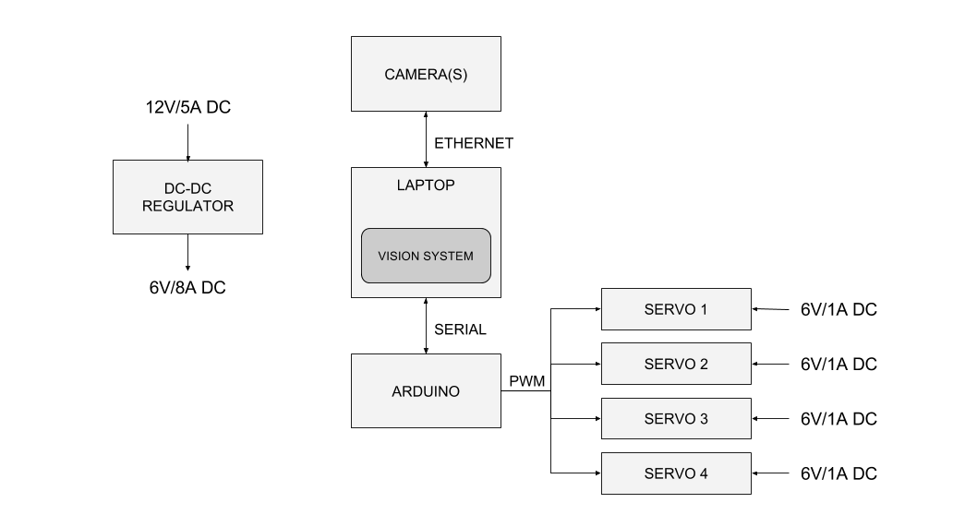

## My Role

My primary role in the project will be the programming of the robotic arm algorithms, the machine vision algorithms and the communication protocols between the laptop and the Arduino board. I plan on writing most code in C++ (Arduino) and Python (serial communication).

## Initial Plan of Action

Initially the most important thing is to get a prototype of the base built so that we can put together our robotic arm and begin getting the library for arm movement built. I think a good first step would be to be able to play the game using manual input from a computer. This would demonstrate the ability to quickly send commands from laptop to Arduino as well as check the movement algorithms of the robotic arm. The machine vision and automation will come next, as well as making any mechanical improvements to the arm if needed (new material, new servos etc.)